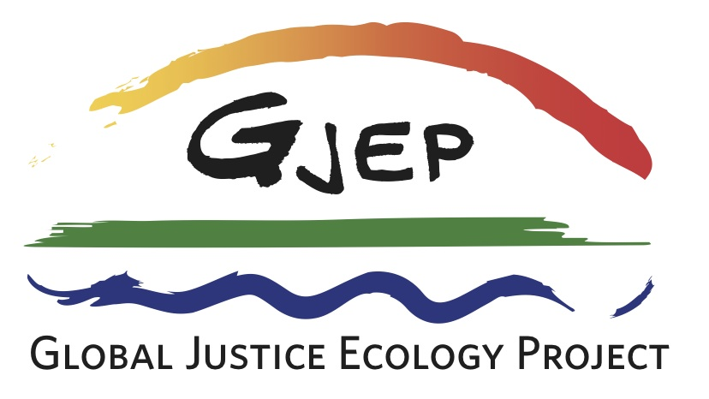

GJEP Board of Directors

Nnimmo Bassey
Director
Health of Mother Earth Foundation
Steering Committee
Oilwatch International
Benin City, Nigeria

Lindsey Gillies
Certified Nurse Midwife
Women's Health Nurse Practitioner
Boston, Massachusetts

Ann Lipsitt
Literacy Specialist
Fiber Artist
Essex Junction, Vermont

Zahra Moloo
Journalist & Filmmaker
ETC Group
Montreal & Nairobi, Kenya

Alejandra Parra
Founder
Red de Acción por los Derechos Ambientales
Latin American Team
Global Alliance for Incineration Alternatives
Temuco, Chile

Karen Pickett
Media Consultant
Bay Area Coalition for Headwaters Earth First!
Canyon, California

Cassandra Smithies
Author, Researcher,
Translator, Sculptor, Painter
New York, New York

In memoriam

Soren Ambrose

Dr. Aziz Choudry

Dr. Will Miller
Donating Stock to the Global Justice Ecology Project

To donate stock to the Global Justice Ecology Project, please contact your broker with the information below and then contact GJEP Executive Director Anne Petermann to let her know about your gift, or if you have any questions.
Information for your Broker:
1st Clearing Corp DTC 0141
Further Credit: Boenning and Scattergood.
For the account of: Global Justice Ecology Project Inc.
Account Number 34575933
Information to contact Anne Petermann, GJEP Executive Director:
anne@globaljusticeecology.org
+1 (716) 364-1188

Thank you for your generous gift!

